**By: Nikita Mehta**

**Charmy Shah**

**Business Model Canvas Report**

**Business Canvas Model:**

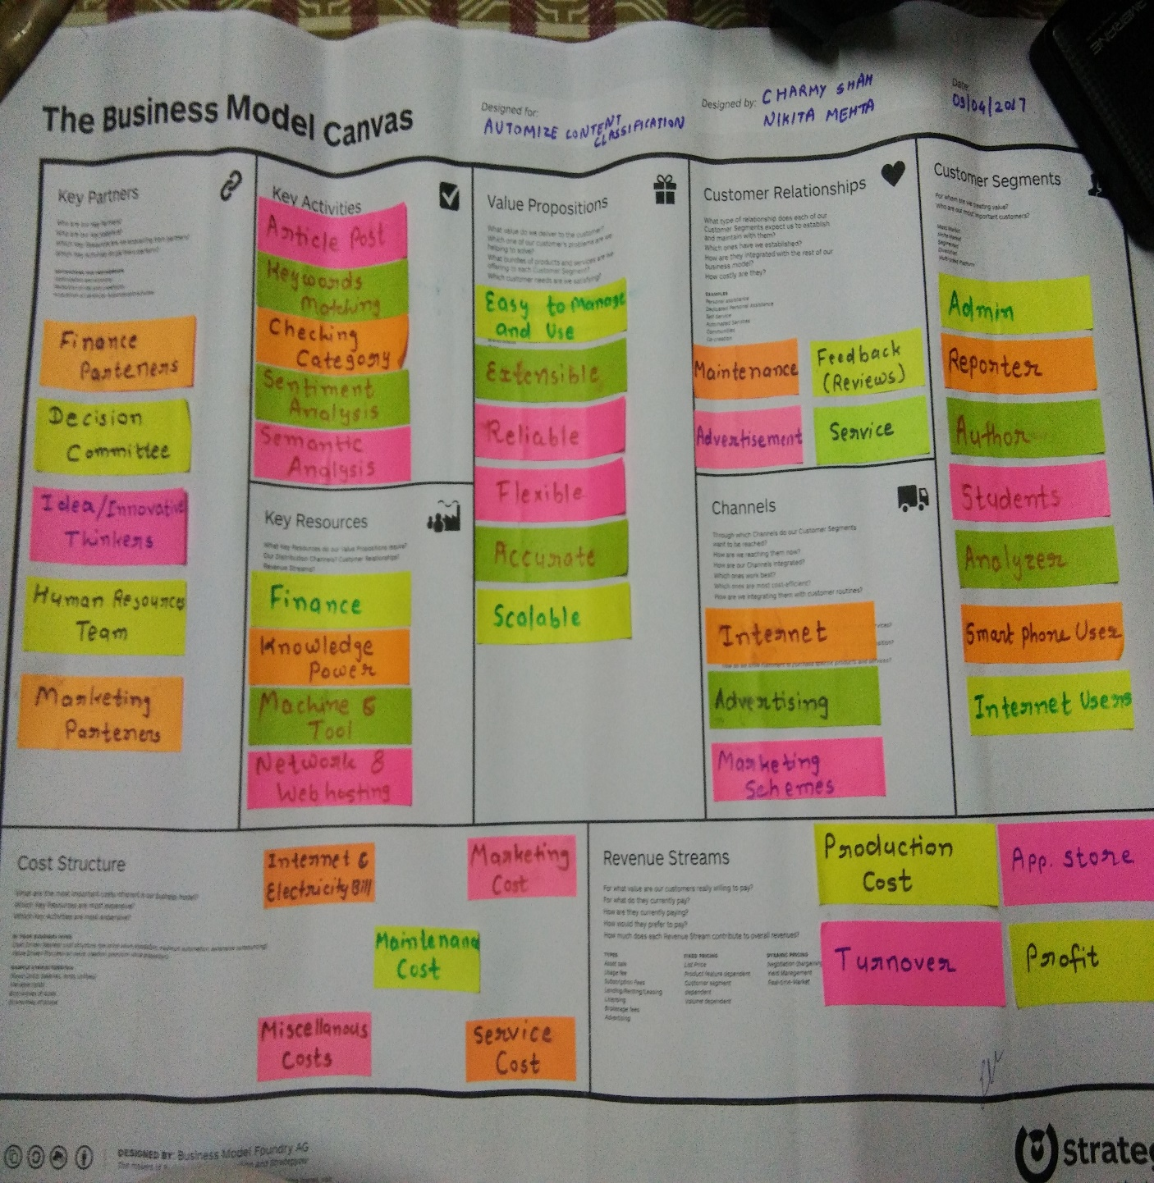

* **KEY PARTNERS:**
* **WiFi Providers:**

Such partners would always avail this opportunity to get maximum out of the system. They will use and buy this system as they will get easy and convenient administrator portal.

* **Management Consultancies:**

The Management committee includes the main management makers regarding our application. The application will help them in making decisions, costing, auditing and forecasting about trends.

* **ERM software providers:**

ERM software Providers are the firm who are more entangled to provide sophisticated software to client to make their Entity Relationship more stronger.

* **KEY ACTIVITIES:**
* **Article Post:**

In Article post unit one can post the article and within few seconds get the result about category of article. These articles can be a very invaluable source of knowledge and information.

* **Keywords Matching:**

Keywords matching is useful to match the keywords of the article to the database.

* **Checking Category:**

By checking categories in our website one can easily identify the category of the article.

* **Sentiment Analysis:**

Our algorithm-based sentiment analysis tools can handle huge volumes of customer feedback consistently and accurately. Paired with text analysis, sentiment analysis reveals the customer’s opinion about topics ranging from your products and services to your location, your advertisements, or even your competitors.

* **Semantic Analysis:**

**Machine-driven semantic analysis has a number of real world applications. It helps:**

* Extract relevant and useful information from large bodies of unstructured data.
* Find an answer to a question without having to ask a human
* Discover the meaning of colloquial speech in online posts
* Uncover specific meanings of words used in foreign languages mixed with our own.
* **KEY RESOURCES:**
* **Finance:**

Financial support for the key activities of the company, man-power, technical resources and functionality of the company.

* **Knowledge Power:**

Knowledge Power is the base of the development of our website. It includes a set of people who contribute various thoughts and ideas for the betterment of our website.

* **Machines and Tools:**

Machines include laptops, mobile units and PCs on which development of the website occurs. Company employees need machines to perform. Tool resources are diverse. Different types of tools include online tools such as VC control and testing tools. Software tools include IDEs such as Eclipse and also anti-virus software such as Quick Heal and McAfee.

* **Networks and Web Hosting:**

High-speed wireless or wired network support is necessary for the basic functionality of the company. Moreover, web hosting support would be needed for online hosting, connectivity and website storage/launching.

* **VALUE PROPOSITIONS:**
* **Easy to manage and Use:**

Our website is very user friendly. Everyone easily understand the functionality of our website. It can manage easily.

* **Extensibility:**

Extensibility is a software engineering and systems design principle where the implementation takes future growth into consideration. The term extensibility can also be seen as a systemic measure of the ability to extend a system and the level of effort required to implement the extension.

* **Reliability:**

The ability of an apparatus, machine, or system to consistently perform its intended or required function or mission, on demand and without degradation or failure.

* **Flexible:**

Our system is able to be easily modified to respond to altered circumstances.

* **Accurate:**

Our system is able to give an accurate result.

* **Scalable:**

Scalability is the capability of a system, network, or process to handle a growing amount of work, or its potential to be enlarged in order to accommodate that growth.

* **CUSTOMER RELATIONSHIPS:**
* **Feedback (Reviews):**

Feedback will be a way for the user to provide his/her view of the website. The user can also rate our website from different angles so that the management of our website can figure out fields for improvement. Users can also give their good/bad reviews on the article.

* **Maintenance:**

Maintenance helps customers with specific technical problems or improvements. The website must be maintained keeping in mind the preservation of regular customers and the attraction of new/potential ones.

* **Services:**

Our system provides different types of services such as posting article, searching article on specific topic, allow to give feedback/reviews on the article, etc.

* **Advertisements:**

Advertisements are a major mode of communication between any company and the company’s current or future customer base. Advertisements are distributed among social media, internet, television, newspapers, radio stations and magazines to reach a wide population. They attract viewers towards using the company’s certain product or feature.

* **CHANNELS:**
* **Marketing Schemes:**

Marketing Schemes are different marketing techniques that work towards propagation of the use of the product in the market among the wide customer base.

* **Advertising:**

Advertising is a major channel which is a type of a marketing scheme. Information about the product is over-exaggerated and spread throughout the potential customer base.

* **Internet:**

In today’s world, almost all the youth and young adults are users of the internet in one way or another. Advertisements of products are spread out through the internet on different websites, mobile apps and videos. Besides advertisements, the official websites of the product or company are also widely viewed by the user base.

* **Promotion Activities:**

Promotion activities have become a hit in today’s world for propagating the use of a certain products. What users and customers need in today’s busy world is a small boost towards purchasing/using a product. This boost may be in the form of a discount for new users, some sale, and added features for a specific time periods, etc. These activities promote the use of the product, thus the name.

* **CUSTOMER SEGMENTS:**
* **Admin:**

Site administrators can perform administrative functions such as modifying site pages, adding events, and customizing the contact database. Administrator can log in and access the admin backend – an area reserved for site and account administration, and not seen by ordinary members or visitors to your site.

* **Reporters:**

Reporters can post the article on our website and easily identify the main topic of the article and then post it in the appropriate blog. They can also read different articles and enhance their knowledge.

* **Authors:**

Authors can post their articles on our website. They can also post their books on it. By this they can increase their fan following.

* **Smart Phone Users:**

Our system is a website. So user can also access it by their smart phones. Now-a-days all have smart phones so we build a responsive website so that everyone can use from any resources.

* **Internet Users:**

Over 75% of the population uses the internet today. With so many user of the internet, there surely is a good proportion of that percentage who has the habit of goggling certain words, phrases or concepts to get a useful result. Our website will be highly used by such people.

* **Students:**

Our website is very useful for students for research and development. They can easily get content for any topic from our website.

* **Analyser:**

An analyser is a person or device that analyses given data. It examines in detail the structure of the given data and tries to find patterns and relationships between parts of the data. An analyser can be a piece of hardware or a computer program running on a computer.

* **COST STRUCTURE:**
* **Service Cost:**

The costs associated with helping customers and providing them with compensation in case of a fault of the company.

* **Maintenance Cost:**

Cost of the website’s maintenance and maintenance of the machines, devices and other operational functionalities.

* **Marketing Cost:**

Advertising and marketing costs to be paid to advertising agencies, websites, apps, newspapers, television or play-stores.

* **Internet and Electricity Bill:**

The cost of network facilities and high-speed internet varies according to the usage of the company. The electricity costs of our company would be high due to heavy computer work and heavy use of electronic devices and main-streamservers.

* **Miscellaneous Costs:**

Other costs such as accidental damage, damage done by viruses, power failure, damage of components, etc.

* **REVENUE STREAMS:**
* **Turnover:**

The turnover is the total amount the company has at the end of the year.

* **Production Cost:**

For our project, the cost to develop the website, such as software/hardware costs and other employee/service costs.

* **Profit:**

The amount earned by the website.

* **App-Store:**

The app-store provides the facility of displaying the app to users so that they can directly buy or install it.